SIF Framework (.NET)

Version

**Author:** , SIF Solutions Architect

**Revision:** 2.0

**Published:** May 2022

Copyright © 2022,

Table of Contents

1. Introduction 3

2. Exercise 1: SIF Framework Setup 3

2.1. Prerequisites 3

3. Exercise 2: Student Consumer 3

3.1. Prerequisites 3

3.2. Configuration 4

3.3. Implement a student data model class 4

3.4. Implement the student Consumer 5

3.5. Implement the Program class 5

3.6. Test the student Consumer 6

3.7. Advanced exercise 6

4. Exercise 3: Student Provider 6

4.1. Prerequisites 7

4.2. Configuration 7

4.3. Implement a student data model class 7

4.4. Implement the student service interface 8

4.5. Implement the student Provider 8

4.6. Implement the Program class 9

4.7. Create a new Environment for the student Provider 10

4.8. Start the student Provider 11

4.9. Test the student Provider 11

4.9.1. Postman (Chrome Plugin) 11

4.9.2. Check your student Consumer (optional) 12

4.10. Advanced Exercise 12

5. Exercise 4: Service Paths 13

5.1. Pre-requisites and configuration 13

5.2. Provider implementation 13

5.3. Consumer implementation 13

6. Important notes 13

6.1. Invalid session state 13

# Introduction

Before attempting the exercises in this document, it is assumed that the following documents have already been read:

* Developer Guides\SIF Framework Setup Guide
* Developer Guides\Implementing a SIF Consumer
* Developer Guides\Implementing a SIF Provider

The exercises presented here run the demo projects included with the SIF 3 Framework and rely heavily from the information presented in the above documents.

# Exercise 1: SIF Framework Setup

**Task:**

* Download the SIF Framework
* Load the SIF Framework Projects into Visual Studio
* Create an Environment
* Start the Environment Provider
* Start the demo student Provider
* Run the demo student Consumer

## Prerequisites

Work through the instructions from the “SIF Framework Setup” document.

# Exercise 2: Student Consumer

**Task:**

* Implement a student Consumer from scratch

## Prerequisites

Work through the instructions from the “Implementing a SIF Consumer” document. This section supplements the information provided in that document. It is assumed that a SQL Server LocalDB database will be used for these exercises.

For a definition of the *Sessions* database table, refer to the *Scripts\SQL\Entity Framework Core\Sessions table\Create Session database table - 6.0.0 (LocalDB).sql* SQL script file. Either create the Consumer database beforehand or use Entity Framework Core to automatically generate it for you.

## Configuration

In the *appsettings.json* configuration file, set the following properties:

* “consumer.environment.sharedSecret”: “SecretDem0”
* “consumer.environment.url”: “https://localhost:7009/api/environments/environment”
* “consumer.environment.template.applicationKey”: “Sif3DemoAspNetCoreConsumer”
* “consumer.environment.template.authenticationMethod”: “Basic”
* “consumer.environment.template.dataModelNamespace”: “http://www.sifassociation.org/datamodel/au/3.4”
* “consumer.environment.template.instanceId” (remove)
* “consumer.environment.template.solutionId”: “Sif3Framework”
* “consumer.environment.template.userToken” (remove)

These properties have been predefined to work with the demonstration projects included with the SIF Framework.

In addition, add a ConnectionStrings DefaultConnection property for the database.

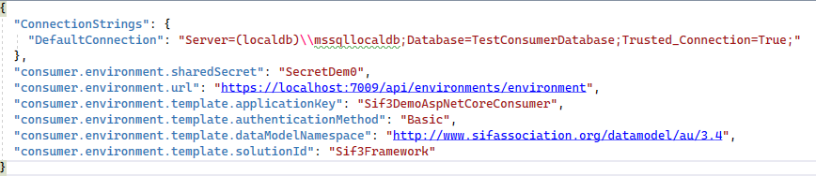

Figure 1: SIF Consumer appsettings.json

## Implement a student data model class

For implementing the Consumer, a SIF Data Model object needs to be specified. In this exercise, create a student data model based upon the SIF AU StudentPersonalType type. Create a “Models” folder with a new StudentPersonal class that implements the IDataModel interface and extends the SIF AU StudentPersonalType type available from the Sif.Specification.DataModel.Au NuGet package. Note the use of XML serialization attributes in the StudentPersonal class as they are critical for meeting the SIF Specification.

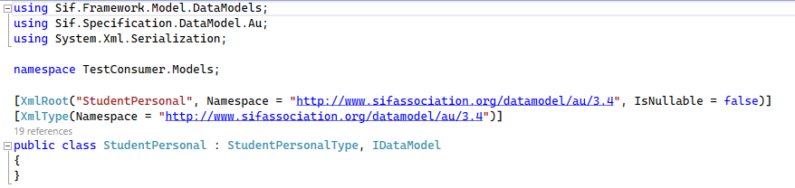

Figure 2: StudentPersonal data model class

## Implement the student Consumer

To implement the Consumer, create a “Consumers” folder with a new StudentPersonalConsumer class that extends the BasicConsumer class with the previously defined StudentPersonal class as the generic type. Implement the constructor that takes the applicationKey, instanceId, userToken and solutionId parameters to simply call upon the “base” constructor.

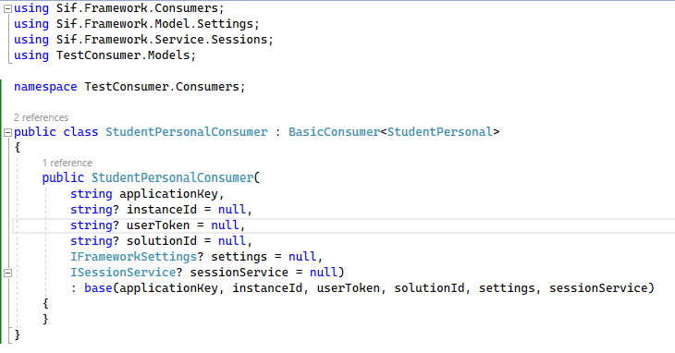

Figure 3: StudentPersonal Consumer class

## Implement the Program class

In the Program class, instantiate the new StudentPersonalConsumer class and call the Register(), Query() and then Unregister() methods, writing the student details retrieved to the console.

For instantiating the StudentPersonalConsumer class, the applicationKey and solutionId values can be read from the appsettings.json file.

For the settings parameter, pass an instance of the Sif.Framework.Settings.ConsumerSettings class (which requires an instance of IConfiguration) which provides access to the properties in the appsettings.json configuration file.

For the sessionService parameter, it is recommended that Dependency Injection is used to create instances of SessionDbContext, Repository<Session, Guid> and ObjectService<Session, Guid> classes. The sessionService is used for the storage and retrieval of session tokens to and from a database.

The code snippet below uses a .NET Generic Host to manage application configuration and Dependency Injection. It also creates the required database if it does not exist.

**IMPORTANT:** Ensure that the Unregister() method is always called from within a “finally” block that encompasses all Consumer (service) calls. This will prevent the Consumer from having an invalid state should the Consumer fall over at any point. For more information, refer to section “6.1 Invalid session state”.

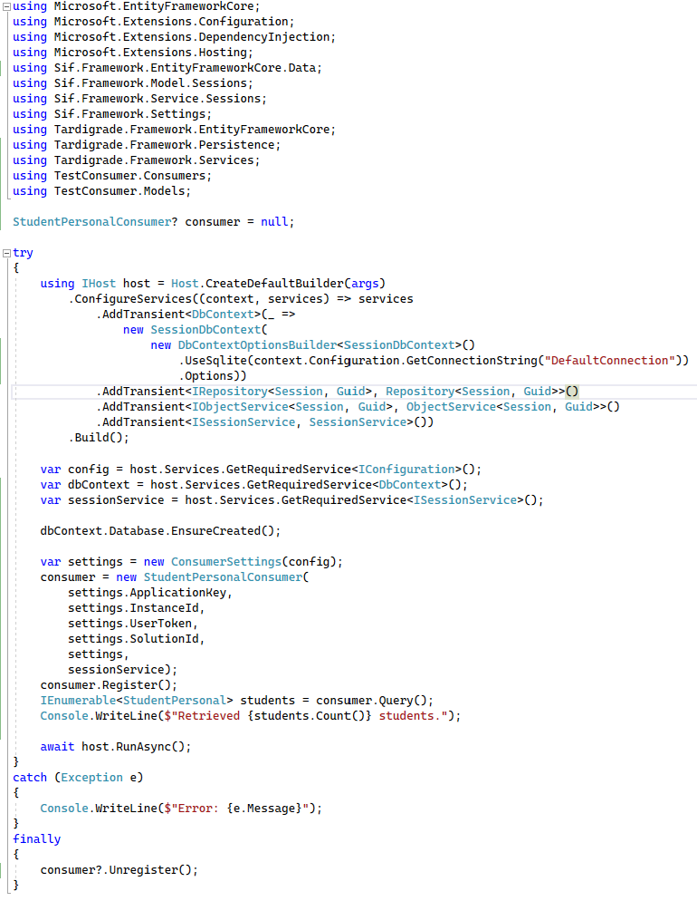

Figure 4: Student Consumer Program class

## Test the student Consumer

To test the newly created student Consumer, repeat Exercise 1. However, instead of running the demonstration Consumer using the *Scripts\BAT\Demo execution\NetCore\DemoConsumer.bat* script, run the new Consumer from your project.

## Advanced exercise

If you have successfully completed this exercise and have more time, why don’t you try to “Create” a student?

# Exercise 3: Student Provider

**Task:**

* Implement a student Provider from scratch
* Test using Postman

## Prerequisites

Work through the instructions from the “Implementing a SIF Provider” document. This section supplements the information provided in that document. It is assumed that a SQL Server LocalDB database will be used for these exercises.

As this exercise is based upon a Direct environment, the SIF Provider needs to use the same database connection as the Environment Provider (to reference the same database).

## Configuration

In the appsettings.json configuration file, set the following properties:

* “provider.environment.template.dataModelNamespace”: “http://www.sifassociation.org/datamodel/au/3.4”

These properties have been predefined to work with the demo projects included with the SIF Framework.

In addition, add a ConnectionStrings DefaultConnection property that references the same database as used by the Environment Provider.

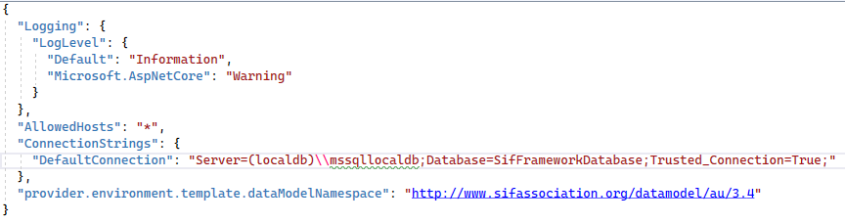

Figure 5: SIF Provider appsettings.json

## Implement a student data model class

For implementing the Provider, a SIF Data Model object needs to be specified. In this exercise, create a student data model based upon the SIF AU StudentPersonalType type. Create a “Models” folder with a new StudentPersonal class that implements the IDataModel interface and extends the SIF AU StudentPersonalType type available from the Sif.Specification.DataModel.Au NuGet package. Note the use of XML serialization attributes in the StudentPersonal class as they are critical for meeting the SIF Specification.

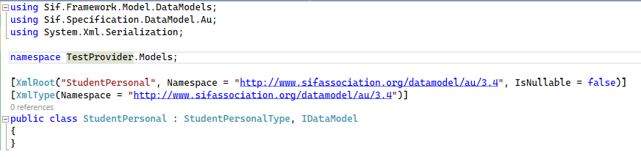

Figure 6: StudentPersonal data model class

## Implement the student service interface

In a new “Services” folder, create a StudentPersonalService class that implements the IBasicProviderService interface with the previously defined StudentPersonal data model class as the generic type. For these exercises, it would be sufficient to only implement one of the Retrieve() methods.

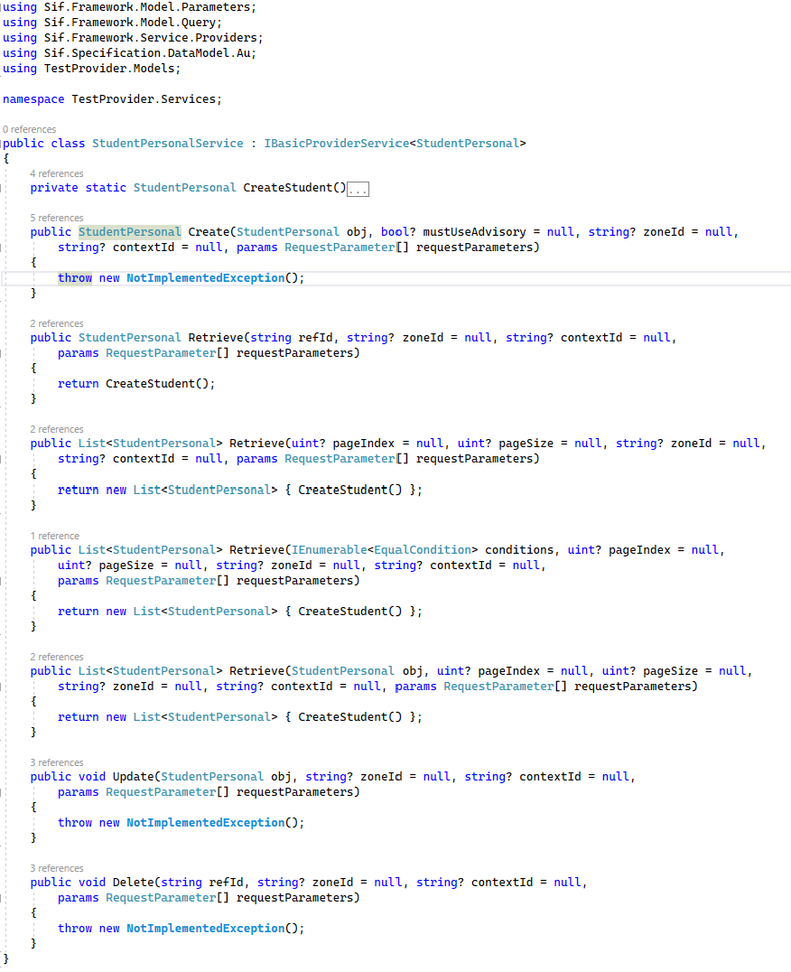

Figure 7: StudentPersonal service class

## Implement the student Provider

To implement the Provider, in the “Controllers” folder create a new StudentPersonal**s**Controller class that extends the BasicProvider class with the previously defined StudentPersonal data model class as the generic type. For the constructor, call upon the “base” constructor of the BasicProvider class.

As we are not implementing SIF Events, annotate the BroadcastEvents method with the [NonAction] attribute.

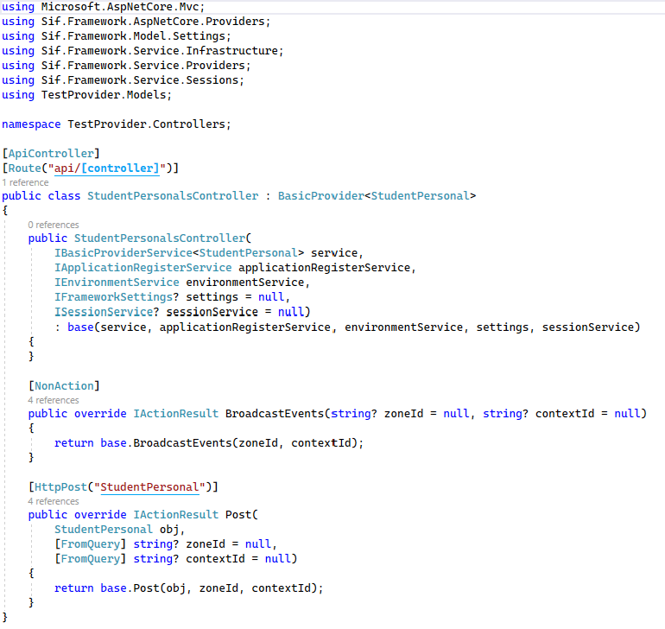

Figure 8: StudentPersonal Provider class

**IMPORTANT:** Ensure that the Controller name prefix is based upon the plural form of the SIF Data Model object, i.e., StudentPersonal**s**.

## Implement the Program class

In the Program class, it is recommended that Dependency Injection is used to create instances of the SifFrameworkDbContext, Repository and service classes required by the SIF Provider constructor.

The service parameter takes the StudentPersonalService class implemented above and is used for the processing of student data requests.

The applicationRegisterService and environmentService parameters are required for the authentication and authorization of calls from a SIF Consumer.

For the settings parameter, define an instance of the Sif.Framework.Settings.ProviderSettings class (which requires an instance of IConfiguration) which provides access to the properties in the appsettings.json configuration file.

Although required, the sessionService parameter is only used in a Brokered environment.

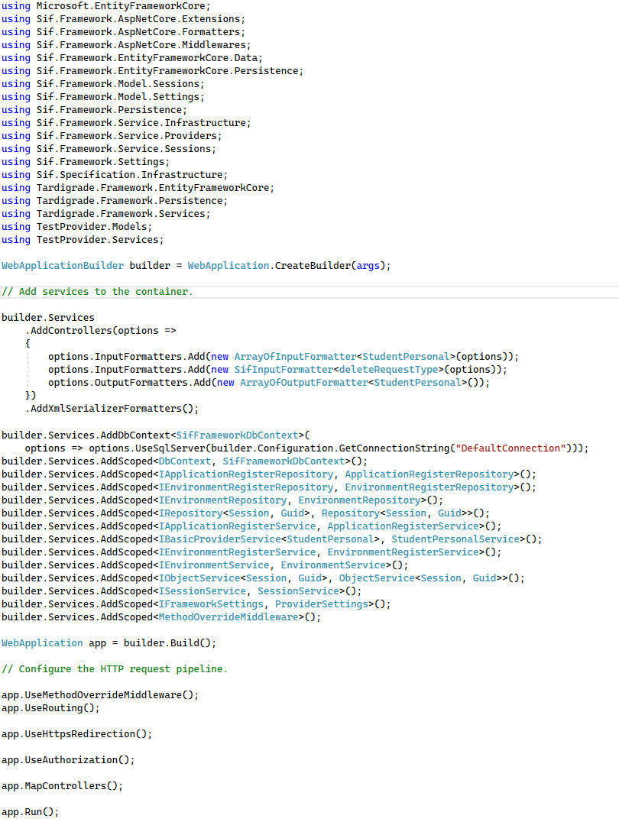

Figure 9: Student Provider Program class

## Create a new Environment for the student Provider

Open the launchSettings.json configuration file of the student Provider project and copy the HTTPS version of the applicationUrl for the profile of the SIF Provider.

In the Sif3FrameworkDemo Solution, edit the *Data files\AU\Sif3DemoAspNetCoreConsumer\EnvironmentResponse.xml* file of the Sif.Framework.Demo.NetCore.Setup Project and replace the scheme and authority of the *requestsConnector* URL (e.g. https://localhost:7207) with that of the new student Provider applicationUrl.

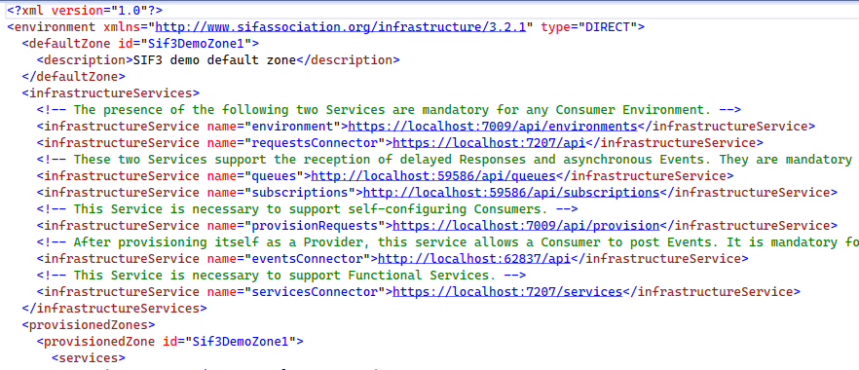

Figure 10: SIF Consumer environment definition

Once done, compile the Sif3FrameworkDemo Solution and re-run the *Scripts\BAT\Demo execution\NetCore\DemoSetup.bat* script. This will update the Environment definition associated with that SIF Consumer to reference the newly created student Provider.

## Start the student Provider

To test the newly created student Provider, repeat Exercise 1 replacing the demonstration Provider with this Provider (ignoring the running of the demonstration Consumer).

## Test the student Provider

### Postman (Chrome Plugin)

To test the student Provider without an actual Consumer, a REST Client is required. For these exercises, the Postman application will be used (<https://www.getpostman.com>). The following steps need to be performed:

* Start with a clean Environment Provider database
* Create an Environment
* Retrieve all students

#### Clear the Environment Provider database

Clear the Environment Provider database using the *Scripts\BAT\Demo execution\NetCore\DemoSetup.bat* script.

#### Create an Environment

Use the POST HTTP method.

Use a URL of <https://localhost:7009/api/environments/environment>.

Use Basic Auth with a Username of “Sif3DemoAspNetCoreConsumer” and a Password of “SecretDem0”. These authentication settings have been pre-defined in the demonstration database using the Sif.Framework.Demo.NetCore.Setup project (refer to the *Data files\AU\Sif3DemoAspNetCoreConsumer\EnvironmentRequest.xml* file).

Provide the following (raw XML) Body with the HTTP request.

<?xml version="1.0"?>

<environment xmlns="http://www.sifassociation.org/infrastructure/3.2.1">

<solutionId>Sif3Framework</solutionId>

<authenticationMethod>Basic</authenticationMethod>

<applicationInfo>

<applicationKey>Sif3DemoAspNetCoreConsumer</applicationKey>

<dataModelNamespace><http://www.sifassociation.org/datamodel/au/3.4>

</dataModelNamespace>

</applicationInfo>

</environment>

**NOTE**: If using cut and paste from this document, beware of whitespace characters such as tabs.

Specify the following headers:

* Content-Type – application/xml
* Accept – application/xml

An appropriate Authorization header is generated from Basic Auth with the provided Username and Password from above.

Once ready, send the POST request and save a copy of the response payload (which should match the *Data files\AU\Sif3DemoAspNetCoreConsumer\EnvironmentResponse.xml* file).

#### Retrieve all students

From the response payload of the Environment POST operation (above), store the <sessionToken> value and the requestsConnector URL.

Use the GET HTTP method.

For the URL, use that returned as the requestsConnector URL, e.g., [https://localhost:<port>/api/StudentPersonals](https://localhost:%3cport%3e/api/StudentPersonals).

Using Basic Auth, set the Username to this <sessionToken> value and a Password of “SecretDem0”.

Specify the following headers:

* Content-Type – application/xml
* Accept – application/xml

Once ready, send the GET request. The response payload should contain a list of students.

### Check your student Consumer (optional)

Run the student Consumer created in Exercise 2 against the newly created student Provider.

## Advanced Exercise

If you have finished the above exercise successfully and have more time, implement remaining methods in the student Provider class.

# Exercise 4: Service Paths

**Task:**

* Implement a Service Path endpoint in the student Provider
* Use the student Consumer to query the Service Path

## Pre-requisites and configuration

Use the student Consumer created in exercise 2.

Repeat the steps in exercise 3 to implement a student Provider. In addition, follow the instructions outlined in the “Enabling Service Paths.docx” document to configure the Provider project appropriately. For a short cut, simply use the student Provider included with the demo project.

## Provider implementation

To create a Service Path endpoint, implement the Retrieve(IEnumerable<EqualCondition>, uint?, uint?, string, string) method of the IBasicProviderService interface for the student service that is passed to the student Provider.

When evaluating the EqualCondition, note that the Left property refers to the SIF data model and the Right property refers to a RefId. To implement a Service Path of the form …/SchoolInfos/{}/StudentPersonals, the Left property of the EqualCondition would be “SchoolInfos” (not SchoolInfo), and the Right property would be the RefId of the queried school. Based on the Conditions passed, return a list of matching students (in this case, all students for the specified school).

To simplify your implementation, simply output the Conditions to the console to ensure that your Service Path endpoint is being hit with the correct values.

## Consumer implementation

The previous exercise should be completed before this to ensure that there is an appropriate Service Path endpoint to query against.

To query the Service Path endpoint of the student Provider, call the QueryByServicePath(IList<EqualCondition>) method of the student Consumer. To query a Service Path of the form …/SchoolInfos/{}/StudentPersonals, create an instance of EqualCondition whereby the value of the Left property is “SchoolInfos” (not SchoolInfo) and the value of the Right property is the RefId of the queried school. Based on the Conditions passed, the call should return all students for the specified school.

# Important notes

## Invalid session state

It is possible for the session state between a SIF Consumer and the EnvironmentProvider to become invalid. The following scenarios are possible:

1. If the sessionToken does not exist in the SIF Consumer’s database but exists in the EnvironmentProvider database, a HTTP status of 409 Conflict may be returned.
2. If the sessionToken exists in the SIF Consumer’s database but does not exist in the EnvironmentProvider database, a HTTP status of 401 Unauthorized may be returned.
3. If the sessionToken in the SIF Consumer’s database does not match the sessiontToken in the EnvironmentProvider database, a HTTP status of 401 Unauthorized may be returned.

The first scenario may occur under the following circumstances:

1. The consumer.environment.deleteOnUnregister setting is “false” and the SIF Consumer database is rebuilt.

The second scenario may occur under the following circumstances:

1. The consumer.environment.deleteOnUnregister setting is “true” and the SIF Consumer completes (or crashes) without calling Unregister(), but the sessionToken is removed from the EnvironmentProvider database (e.g. by running the DemoSetup.bat script).
2. The consumer.environment.deleteOnUnregister setting is “false”, but the sessionToken is removed from the EnvironmentProvider database (e.g. by running the DemoSetup.bat script).

The third scenario may occur under the following circumstances:

1. Manually changing the applicationKey setting in the SIF Consumer’s database.

As a workaround, should any of these scenarios arise during these exercises, it is highly recommended that the demo database be re-created (by executing the *Scripts\BAT\Demo execution\NetCore\DemoSetup.bat* script) and the SIF Consumer database is rebuilt.